Invitation for Expressions of Interest
Banksia Gardens, Broadmeadows
Non-Residential Spaces
EOI Closing Date and Time: 2pm Wednesday, 5 November 2025
OFFICIAL


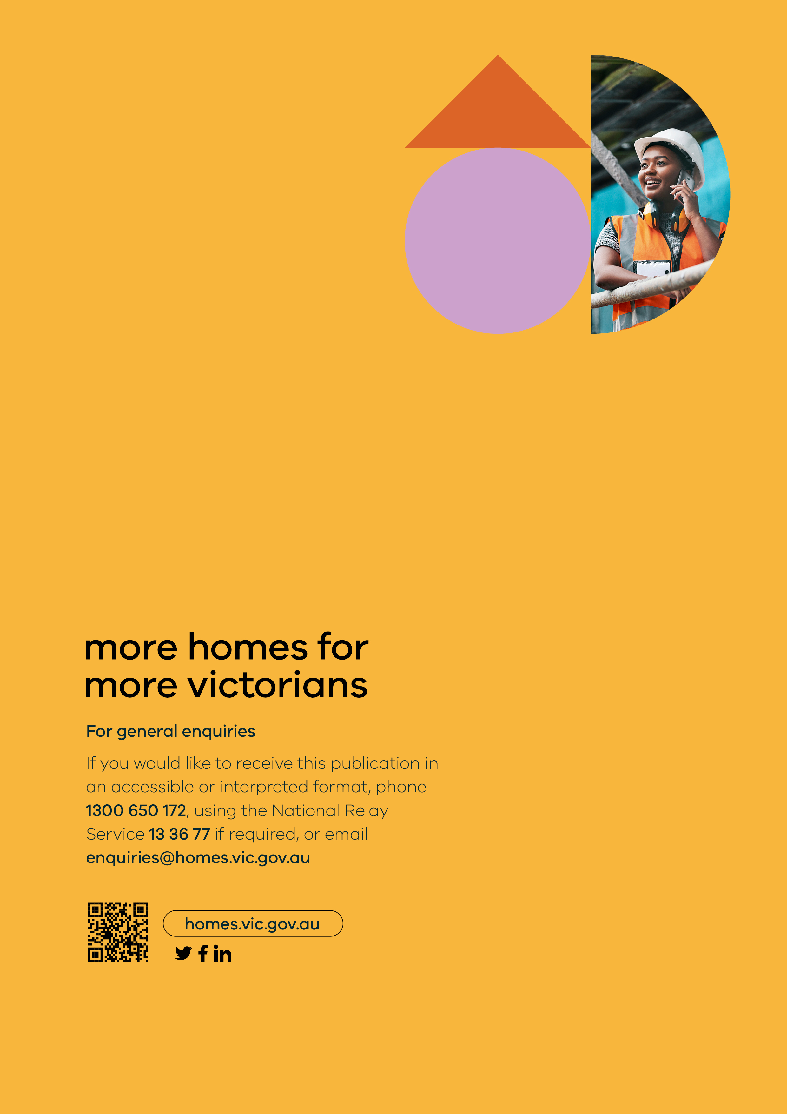

Contents
Contents 3
1 Introduction 4
2 The Opportunity 5
3 Process Matters 7

Introduction

Background
Homes Victoria is delivering new modern, well designed, and energy efficient social housing at Banksia Gardens. The Banksia Gardens development located at 50 Coleraine Street, Broadmeadows will deliver a landmark integrated development of an underutilised site, including 120 new social homes for Victorians (the Site). It is estimated that the new homes will support more than 150 to 200 new residents.
Construction commenced in mid-2024 and the Site is due for construction completion in June 2026 and available for occupation in July 2026. A Community Housing Organisation (CHO) will be selected by Homes Victoria through an upcoming competitive tender process (CHO Procurement Process) to manage the Site on behalf of Homes Victoria for 30 years.
Once completed, the Site will comprise of two separate mid-rise buildings and surrounding garden spaces. Each building (Building A and Building B) currently incorporates a non-residential space on the ground floor which is being delivered as a “cold shell” (Non-Residential Spaces).
Prior to the CHO Procurement Process, Homes Victoria is seeking Expressions of Interest (EOI) from community groups, businesses and non-governmental organisations for use of one or both of the Non-Residential Spaces, to support in the identification of potential users / tenants of these spaces in a coordinated and streamlined manner.
The use of these spaces is intended to support and benefit residents and the local community.

Purpose of the Invitation for EOI
The purpose of this Invitation for EOI is to:
- provide information to community groups, businesses and non-governmental organisations regarding the Non-Residential Spaces available from mid-2026;
- set out the EOI Process and interfaces between the EOI Process with the CHO Procurement Process; and
- invite potential interested users / tenants of the Non-Residential Spaces to submit a EOI for the use of one or both of the spaces (Interested Party).
To support in the preparation of EOIs, a response schedule is provided in Attachment 1 (EOI Response Schedule).

The Opportunity

Key Information on the Non-Residential Spaces
The figures below present an overview of the Site plan. The Non-Residential Spaces are located on the ground floor (street level) of the Site, with Non-Residential Space A (net lettable area (NLA) of ~263m²) positioned at the Coleraine Street end and Non-Residential Space B (NLA of ~217m²) at the Cob Close end.
Figure 1 Banksia Gardens site plan and surrounds
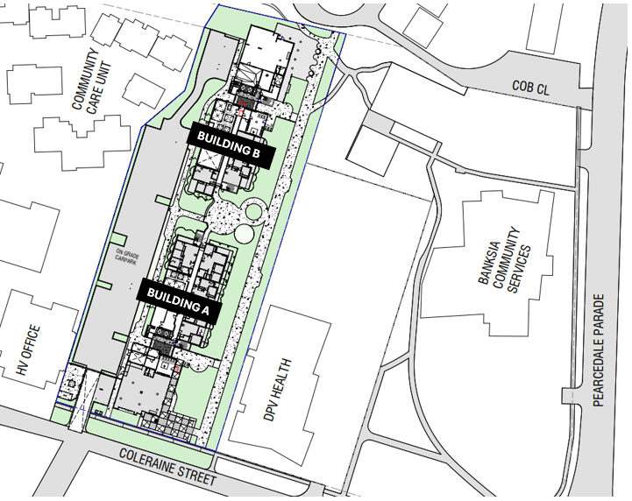
Figure 2 Banksia Gardens Ground Floor layout
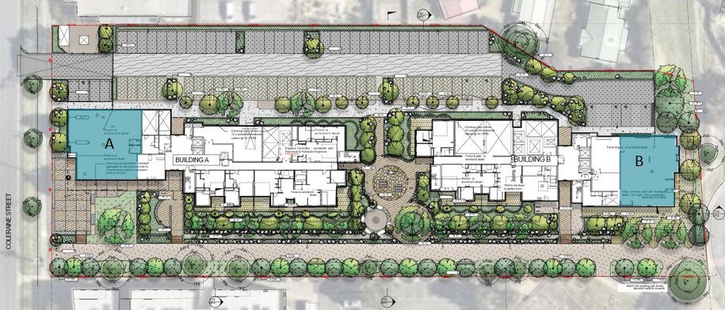
Figure 3 shows concept drawings of the Non-Residential Spaces, which may be subject to change. It is important to note that the spaces will be provided as a “cold shell”, meaning the selected tenant will be responsible for the full costs associated with fitting out the spaces to suit their needs. Designs and materials for a fit-out must be approved by the CHO managing the site and meet fire safety and other requirements established by the CHO and / or required by local and state laws. Additionally, the tenant will be responsible for seeking any council or other approvals relating to the use of the spaces.
Figure 3 Non-Residential Spaces concept drawings
Non-Residential Space (Building A) - 263m² Non-Residential Space (Building B) – 217m²
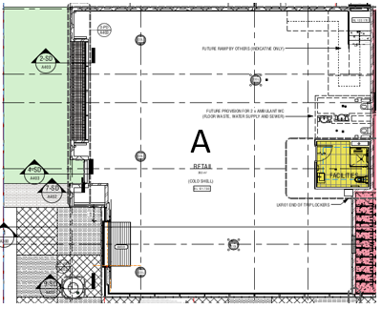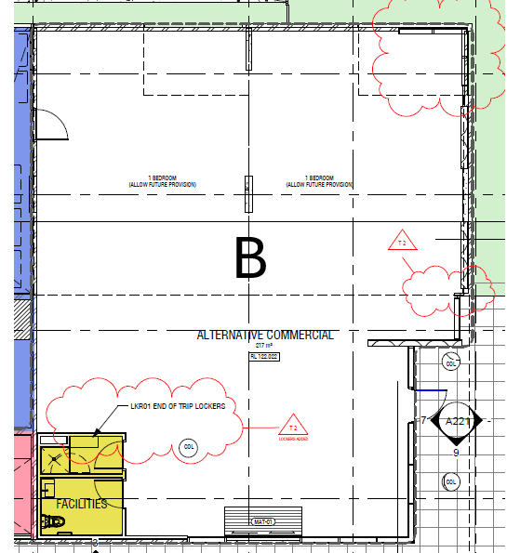
Costs of occupancy
Subject to the process outlined in Section 3.1, lease agreements will be negotiated between the successful CHO and the tenant and will include provisions relating to rent and outgoings. The outgoings may encompass operational expenses such as rubbish removal, maintenance, utility usage, and other property management services.
Partnership or Consultation with CHOs
Community groups, businesses and non-governmental organisations who are interested in submitting an EOI may wish to contact CHOs who may be interested in applying to manage the site long-term through the CHO Procurement Process to explore partnership opportunities and inform their EOI application.

Process Matters

EOI Process and CHO Procurement Process
The release of this Invitation for EOI represents the commencement of the EOI Process.
This EOI Process conducted by Homes Victoria is designed to inform the potential identification of potential tenants for the Non-Residential Spaces.
Respondents’ EOIs will be assessed against the Evaluation Criteria (see Section 3.3), and a report summarising Homes Victoria’s findings (the Report) will be prepared. The Report will be provided to registered CHOs as part of the CHO Procurement Process. CHOs will be required to utilise the Report to identify a prospective tenant and or alternative uses for the Non-Residential Spaces and demonstrate that the views expressed within the Report have been given full consideration.
The final tenancy arrangements for the Non-Residential Spaces will depend on several factors, including the CHOs views in respect to the preferred uses of the Non-Residential Spaces, the Interested Party’s bilateral discussions with the CHOs (if applicable), Homes Victoria’s approval of the proposed tenant for the Non-Residential Spaces, and the execution of a lease agreement.
CHO are not permitted to seek exclusivity arrangements with Interested Parties identified through the Report, but may choose to negotiate lease terms bilaterally within Interested Parties.

EOI submission and lodgement requirements
Homes Victoria invites organisations that are interested in occupying one or more of the Non-Residential Spaces to submit an EOI.
Respondents must ensure that their EOI reflects the structure set out in, and contains the information requested within Attachment 1 (EOI Returnable Schedule).
The EOI must be submitted to community.housing@homes.vic.gov.au prior to the EOI Closing Date and Time set out in Section 3.4. Responses that are not submitted by the EOI Closing Data and Time, and/or are incomplete may not be considered by Homes Victoria (at its absolute discretion).
It is permissible to include appendices to the main body of the EOI, however Homes Victoria’s strong preference is to limit the number of appendices. Respondents should not include generic advertising / marketing material.

Evaluation Criteria
Homes Victoria will undertake a qualitative evaluation of each submitted EOI against the Evaluation Criteria presented below.
Table 1 EOI Evaluation Criteria
Criteria | Detail
Local community at the centre | Respondents must demonstrate how the proposed use of the Non-Residential Spaces supports and benefits the local community, including the new residents of Banksia Gardens.
Ability to form partnerships with Community Housing Organisations | Respondents are required to demonstrate how they might form partnerships with Community Housing Organisations, including existing partnerships they may have already established or opportunities they may have already explored or confirmed with CHOs interested in applying to manage the Site.
Rental contribution and lease terms | Respondents are required to outline their proposed commercial terms for the prospective lease(s), including lease term and rent.
Financial sustainability | Respondents must provide evidence of their financial capacity to ensure that all rent and other occupancy expenses can be managed sustainably.

Timelines
The table below sets out the timeframes that apply to this Invitation for EOI. Homes Victoria reserves the right to amend the timelines at any stage at its absolute discretion.
Table 2 EOI Process Timeline
Date | Key Activity
Tuesday, 7 October 2025 | Invitation for EOI for Non-Residential Spaces open (open for 4 weeks)
11am Monday, 13 October 2025 | Information Session (online via MS Teams)
5pm Monday, 27 October 2025 | Final date for submission of questions to Homes Victoria.
2pm Wednesday, 5 November 2025 | EOI Closing Date and Time
Late November 2025 | Homes Victoria Report to be submitted to registered CHOs of the CHO Procurement Process for consideration

Communications

Information Session for Interested Parties
Homes Victoria will be holding an Information Session online via MS Teams to provide additional information on this Invitation for EOI at the time set out in Table 2. A question and answer format will be offered during this session. To register attendance at this information session please email community.housing@homes.vic.gov.au.

Contact and enquiries
Where practicable, all enquiries and clarification questions in relation to the Invitation for EOI should be submitted during the Information Session. Where this is not possible, further enquiries and communications must be submitted in writing to community.housing@homes.vic.gov.au by not later than 28 October 2025

Terms and Conditions
This Invitation for EOI is not binding on any party, including those submitting an EOI, Homes Victoria, or the successful CHO selected to manage the Site. By submitting an EOI, the Interested Party acknowledges that:
- participation in this process does not create any obligation on Homes Victoria or the successful CHO;
- without limitation, the submission of an EOI by an Interested Party does not give rise to any contract governing, or in any way concerning, the EOI Process or other such process;
- this Invitation for EOI and any other information in respect to the Invitation has been provided to Interested Parties by Homes Victoria for information only;
- Homes Victoria reserves the right to modify, suspend, or terminate the EOI Process at its discretion without incurring any liability;
- Homes Victoria may share EOI responses with CHOs as part of the CHO Procurement Process;
- as an Interested Party, you may be contacted by CHOs as part of the CHO Procurement Process; and
- all costs and expenses associated with the preparation and submission of the EOI are the sole responsibility of the Interested Party.

